# Lab 2.4 Use a Sales array

In this exercise, you’ll start with five arrays that represent sales regions, and each array contains four values that represent the quarterly sales for the region. Then, you’ll summarize the data in these arrays in three success alert dialog boxes.

The first one displays sales by quarter:

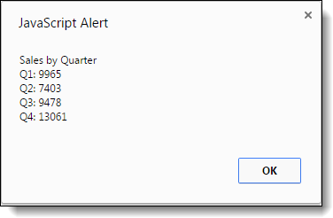

The second one displays sales by region:

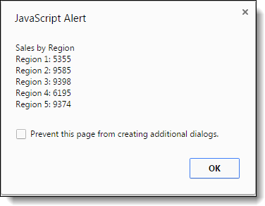

The third one displays total sales for all four quarters and all five regions:

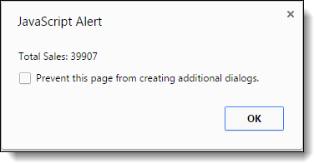

1. Open the HTML and JavaScript files in this folder:

\sales_array\

1. In the HTML file, note that the script element refers to the JavaScript file. In the JavaScript file, note that five arrays are declared with four values in each. Each of these arrays represents one sales region, and each of the values in an array represents one sales quarter. For instance, the sales for the third quarter in region 3 were 2710.
2. Write the code for summing the quarterly sales for each the five regions and displaying the first dialog box above.
3. Write the code for getting the data and displaying the second dialog box above.
4. Write the code for getting the data and displaying the third dialog box above.